ANGEL EATS

Over 100 million tonnes of food are wasted annually in the EU (2014 estimate). If nothing is done, food waste is expected to rise to about 126 million tonnes by 2020.

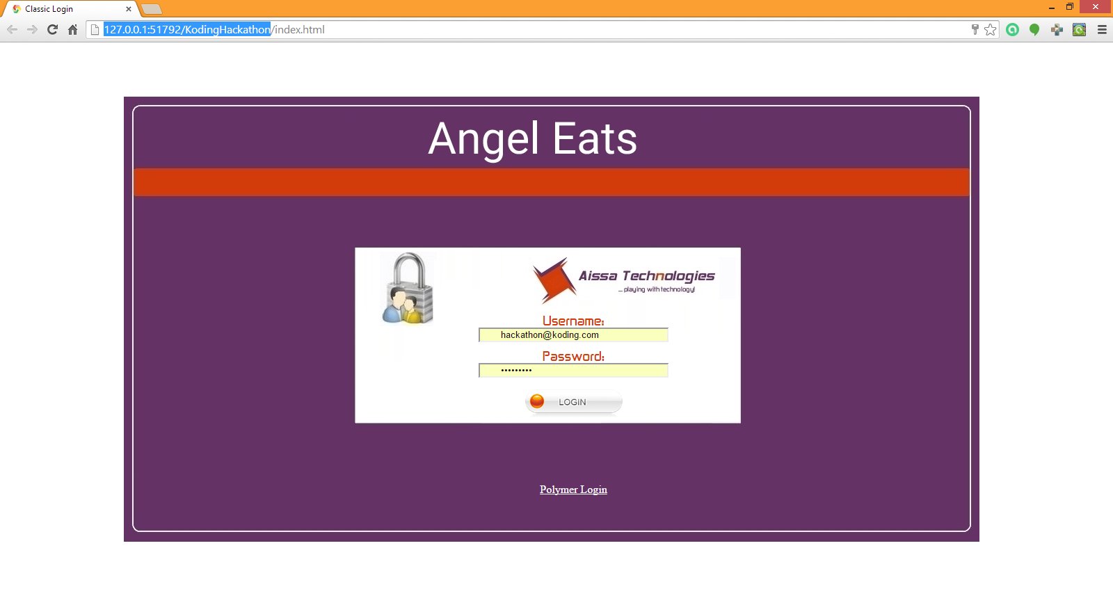
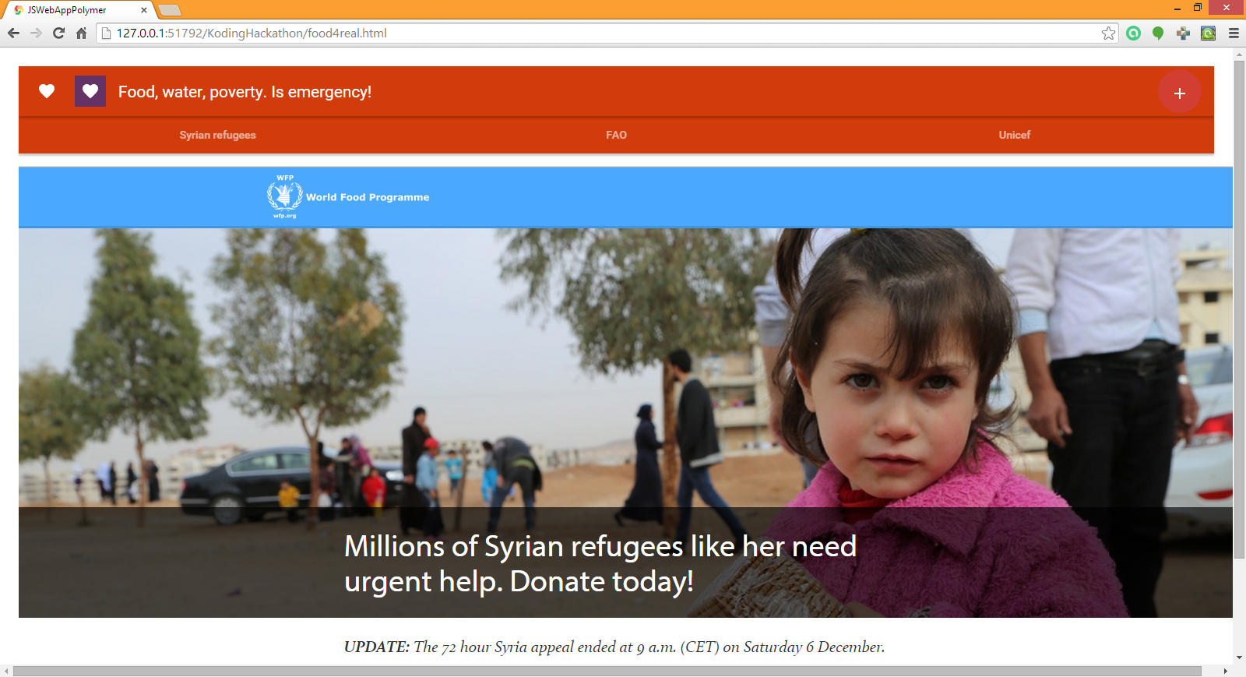

Wasting food is not only an ethical and economic issue but it also depletes the environment of limited natural resources.

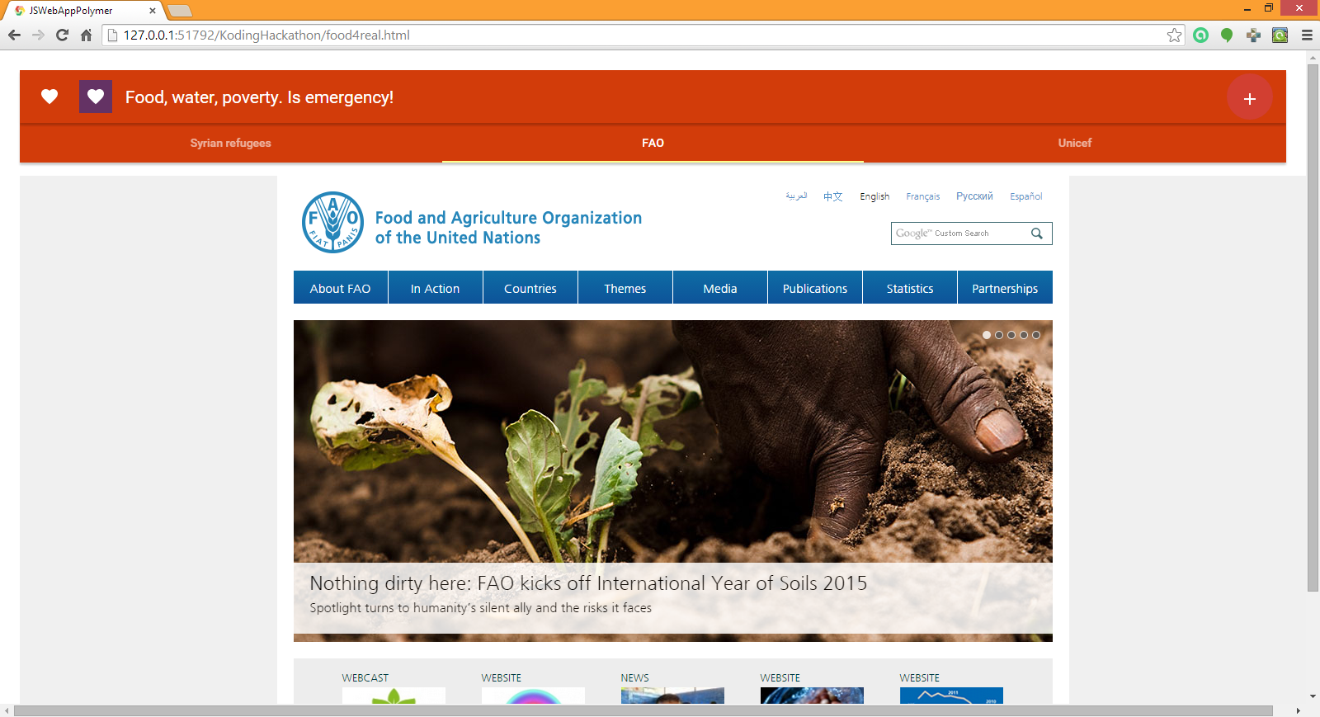
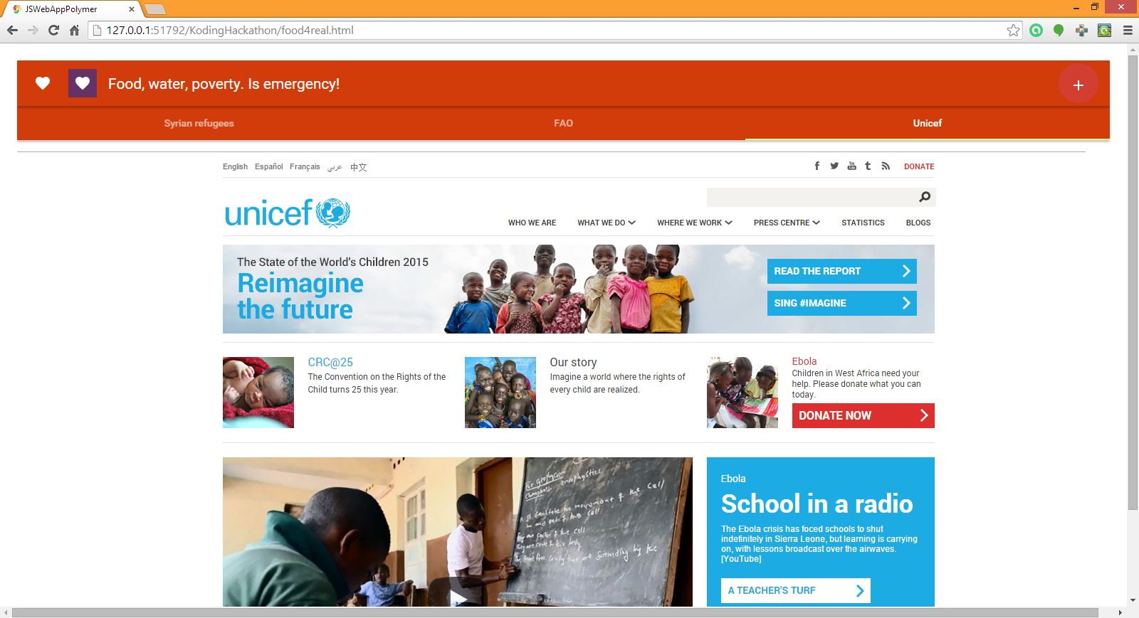

All actors in the food chain have a role to play in preventing and reducing food waste, from those who produce and process foods (farmers, food manufacturers and processors) to those who make foods available for consumption (hospitality sector, retailers) and ultimately consumers themselves Font:European Commission

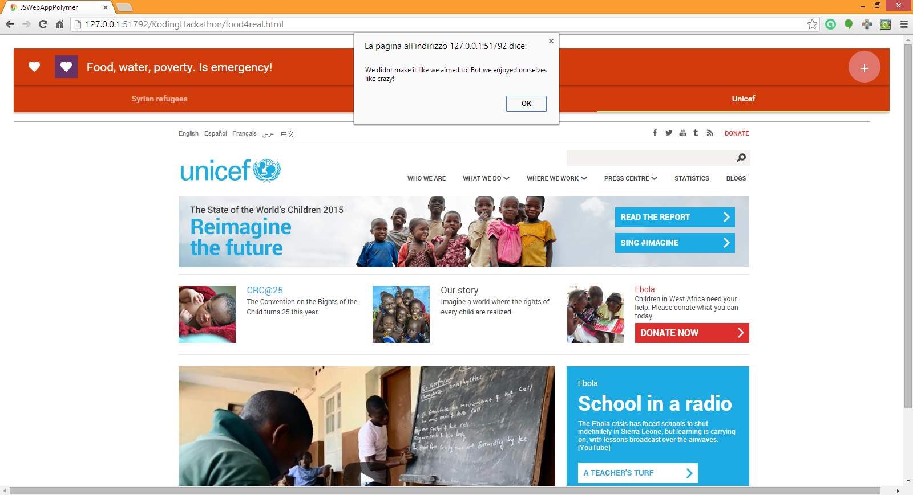
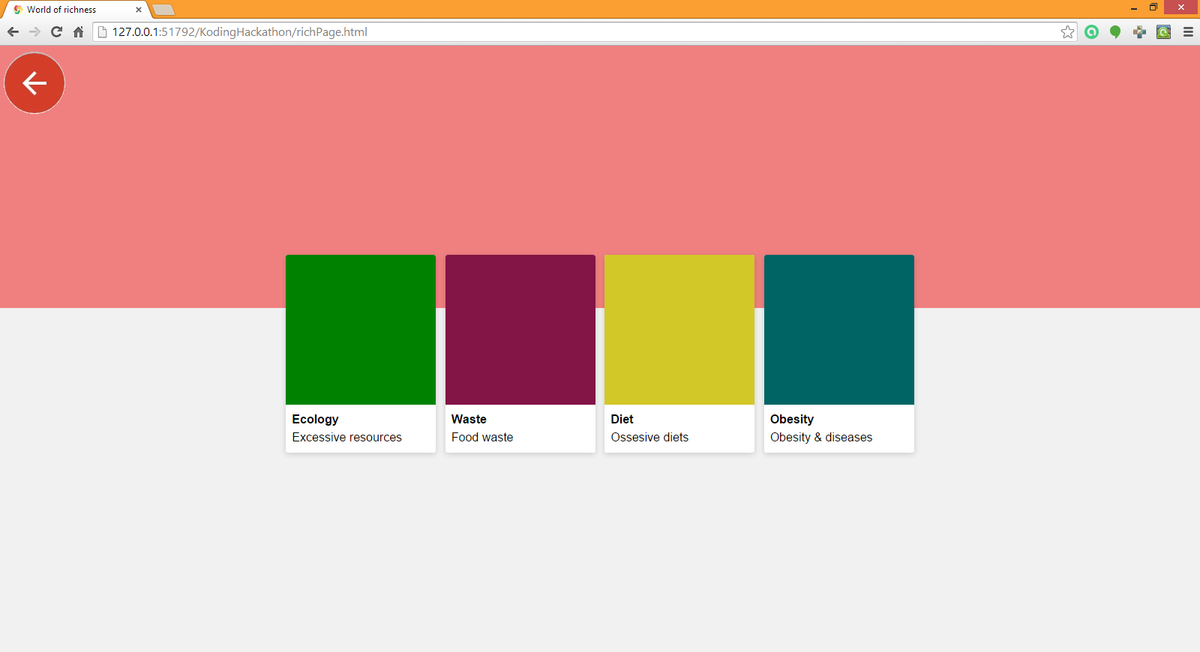
Why resources are under pressure Increase in the sophistication of technology enabling natural resources to be extracted quickly and efficiently. E.g., in the past, it could take long hours just to cut down one tree only using saws. Due to increased technology, rates of deforestation have greatly increased A rapid increase in population that is now decreasing. The current number of 7.132 billion humans consume many natural resources. Cultures of consumerism.

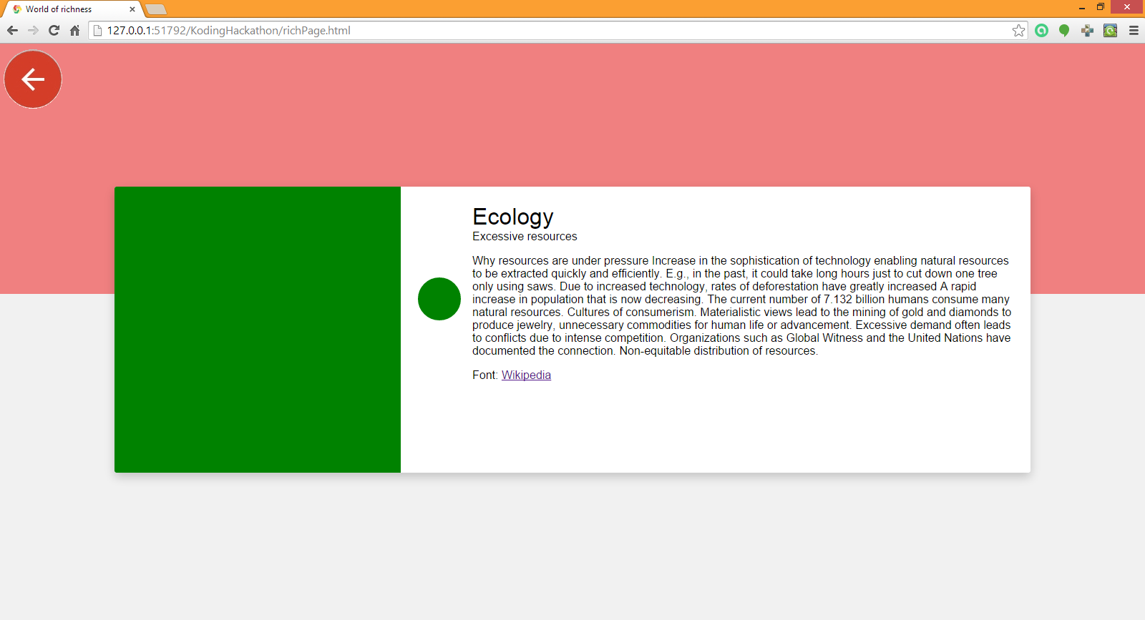
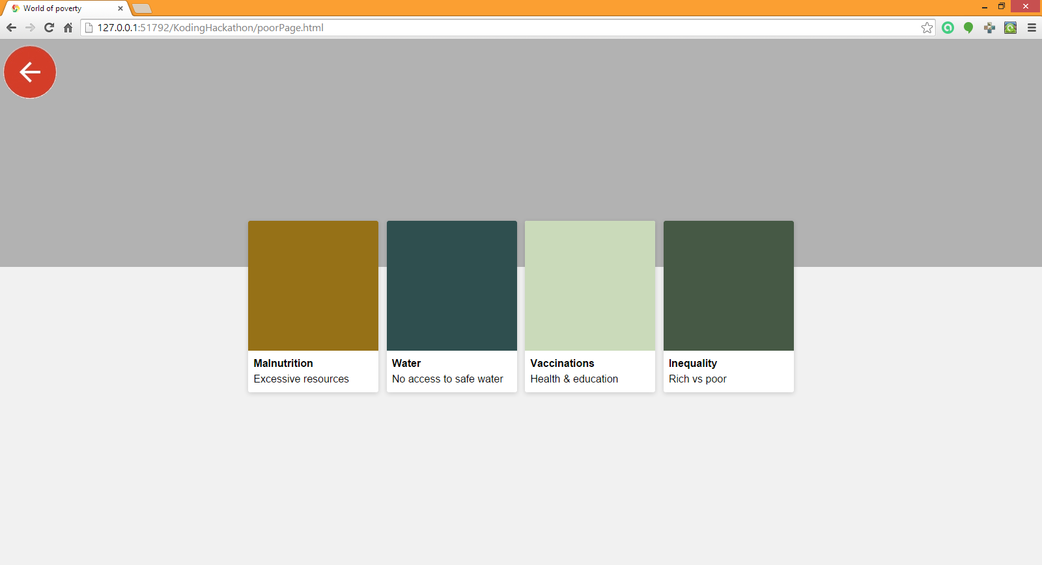

Materialistic views lead to the mining of gold and diamonds to produce jewelry, unnecessary commodities for human life or advancement. Excessive demand often leads to conflicts due to intense competition. Organizations such as Global Witness and the United Nations have documented the connection. Non-equitable distribution of resources.
Font: Wikipedia

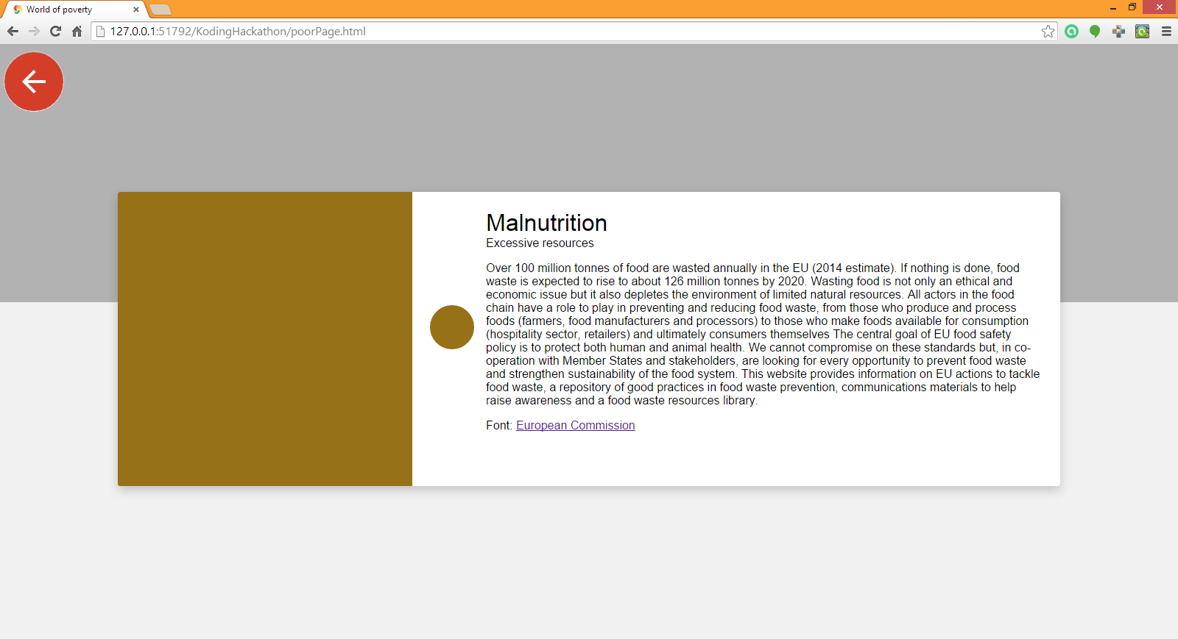

Team Angel Eats @ Koding’s Hackathon 2014

Camelia Boban, developer
Maria Beatrice Kowalska, web & graphic designer

Rome, 6-8 dicember 2014

